# **Name: Abdurrahman Qureshi**

# **Roll No: 210451**

Practical No: 2

**1) WAP to print the greatest of three number using if else ladder.**

**CODE:**

<html>

<head>

<title>EXP 2 - C</title>

<script>

var x = parseInt(prompt("Enter number A : "));

var y = parseInt(prompt("Enter number B : "));

var z = parseInt(prompt("Enter number C : "));

if (x > y && x > z) {

alert(x + " is the Greatest");

document.write(x);

document.write(y);

document.write(z);

} else if (y > z) {

alert(y + " is the Greatest");

document.write(x);

document.write(y);

document.write(z);

} else {

alert(z + " is the Greatest");

document.write(x);

document.write(y);

document.write(z);

}

</script>

<style>

h3 {

color: #ccc;

}

</style>

</head>

<body style="background-color: #111">

<footer>

<h3>Abdurrahman Qureshi</h3>

<h3>210451</h3>

</footer>

</body>

</html>

**OUTPUT:**

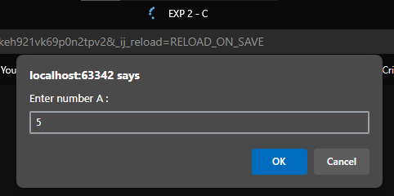 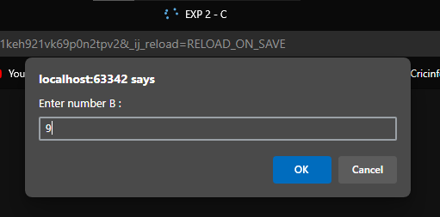

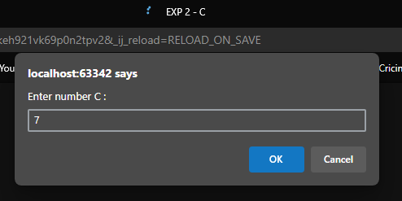 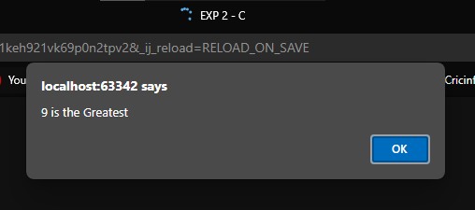

**2) WAP to check if entered is vowel or not**

**CODE:**

<html>

<head>

<title>EXP 2 - B</title>

<script>

let x = prompt("Enter a character : ");

switch (x) {

case "a":

case "A":

case "e":

case "E":

case "i":

case "I":

case "o":

case "O":

case "u":

case "U":

alert(x + " is a vowel");

break;

default:

alert(x + " is a consonant");

break;

}

</script>

<style>

h3 {

color: #ccc;

}

</style>

</head>

<body style="background-color: #111">

<footer>

<h3>Abdurrahman Qureshi</h3>

<h3>210451</h3>

</footer>

</body>

</html>

**OUTPUT:**

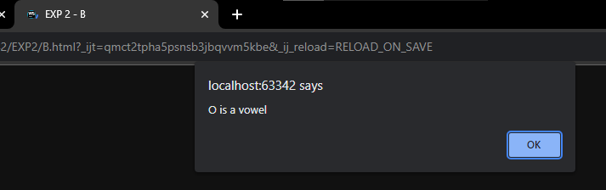 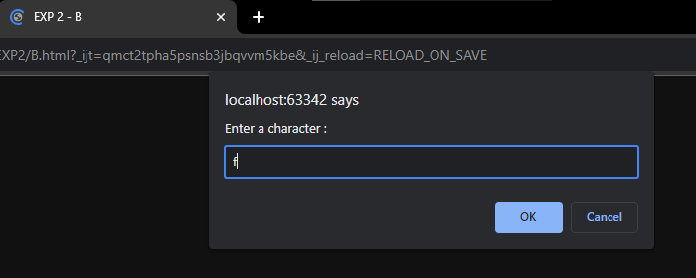

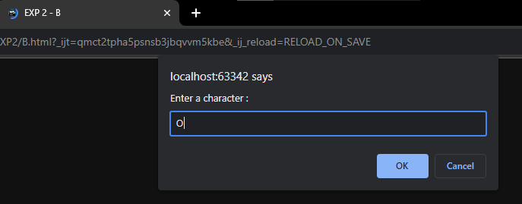 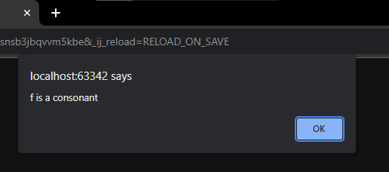

**3) WAP to print odd numbers from 1 to 20 using while loop**

**CODE:**

<html>

<head>

<title>EXP 2 - C</title>

<script>

var x = 1;

while (x <= 20) {

document.write("<h3>" + x + "</h3>");

x += 2;

}

</script>

<style>

h3 {

color: #ccc;

}

</style>

</head>

<body style="background-color: #111">

<footer>

<h3>Abdurrahman Qureshi</h3>

<h3>210451</h3>

</footer>

</body>

</html>

**OUTPUT:**

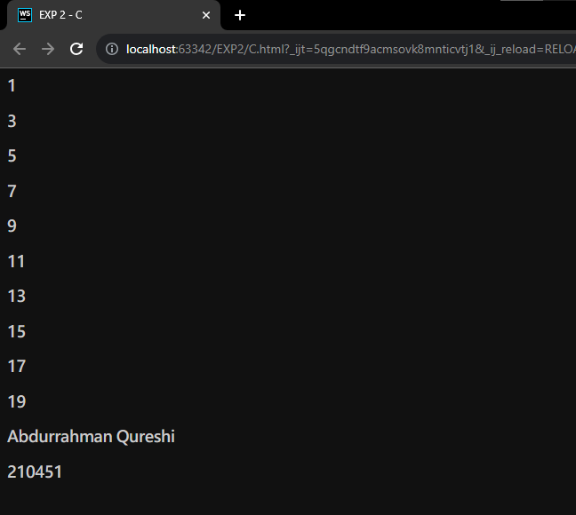

**4) WAP for an Arithmetic Menu**

**CODE:**

<html>

<head>

<title>EXP 2 - D</title>

<script>

let myChoice;

do {

myChoice = prompt(

"1 - Addition\n" + "2 - Subtraction\n" + "3 - Exit\n",

);

myChoice = parseInt(myChoice);

switch (myChoice) {

case 1:

let Ax = parseInt(prompt("Enter number A : "));

let Ay = parseInt(prompt("Enter number B : "));

alert("Addition : " + Ax + " + " + Ay + " = " + (Ax + Ay));

document.write(

"<h3>Addition : " + Ax + " + " + Ay + " = " + (Ax + Ay) + "</h3>",

);

break;

case 2:

let Sx = parseInt(prompt("Enter number A : "));

let Sy = parseInt(prompt("Enter number B : "));

alert("Subtraction : " + Sx + " - " + Sy + " = " + (Sx - Sy));

document.write(

"<h3>Subtraction : " +

Sx +

" - " +

Sy +

" = " +

(Sx - Sy) +

"</h3>",

);

break;

case 3:

alert("Exiting...");

break;

}

} while (myChoice != "3");

</script>

<style>

h3 {

color: #ccc;

}

</style>

</head>

<body style="background-color: #111">

<footer>

<h3>Abdurrahman Qureshi</h3>

<h3>210451</h3>

</footer>

</body>

</html>

**OUTPUT:**

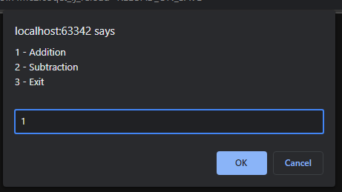 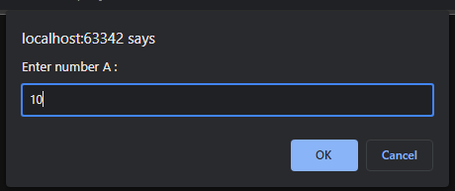

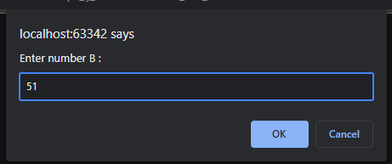 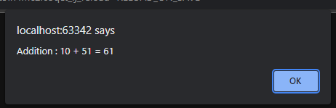

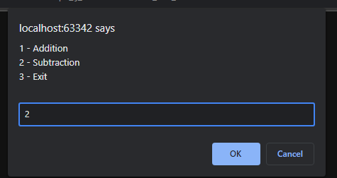 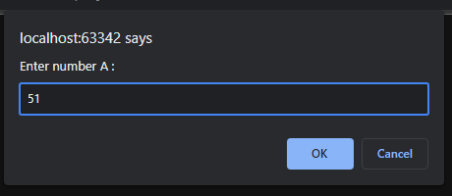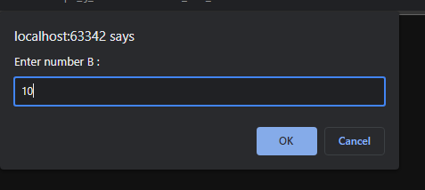 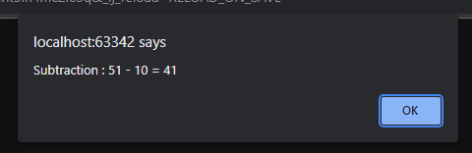

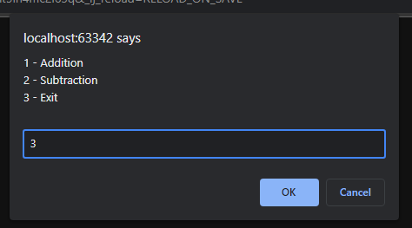 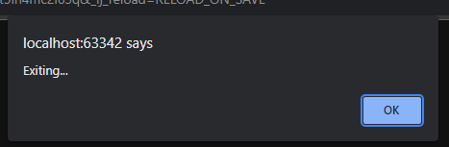

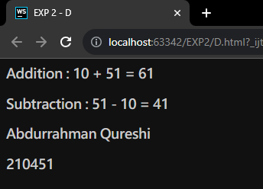

**5) WAP to print a right angled triangle**

**CODE:**

<html>

<head>

<title>EXP 2 - E</title>

<script>

const height = prompt("Enter your desired height for the triangle:");

for(let i = 0 ; i <height ; i++){

for (let j = 0 ; j<=i ; j++){

document.write("*" + " ")

}

document.write("<br/>")

}

</script>

<style>

*{

color: #ccc;

}

</style>

</head>

<body style="background-color: #111">

<footer>

<h3>Abdurrahman Qureshi</h3>

<h3>210451</h3>

</footer>

</body>

</html>

**OUTPUT:**

